**Wubba Lubba Dub Dub’s *Slash ‘N’ Bash***

**Maintenance Plan**

**Costs**

* Server Costs

Amazon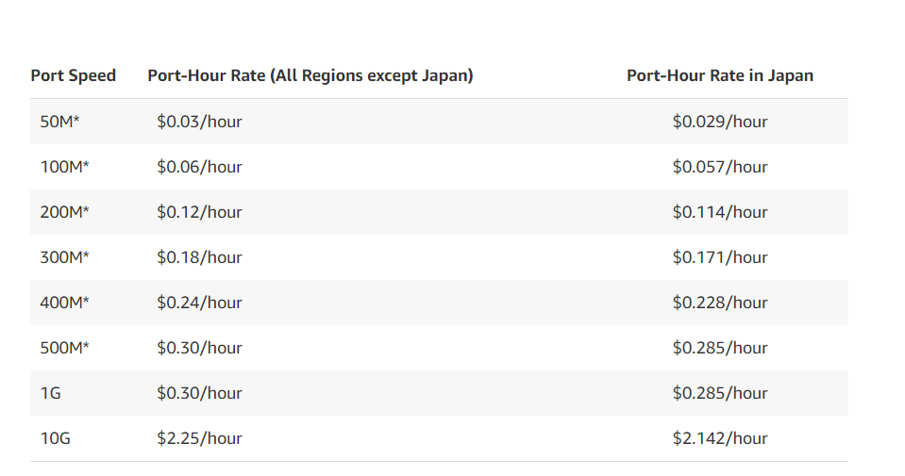

RockSpace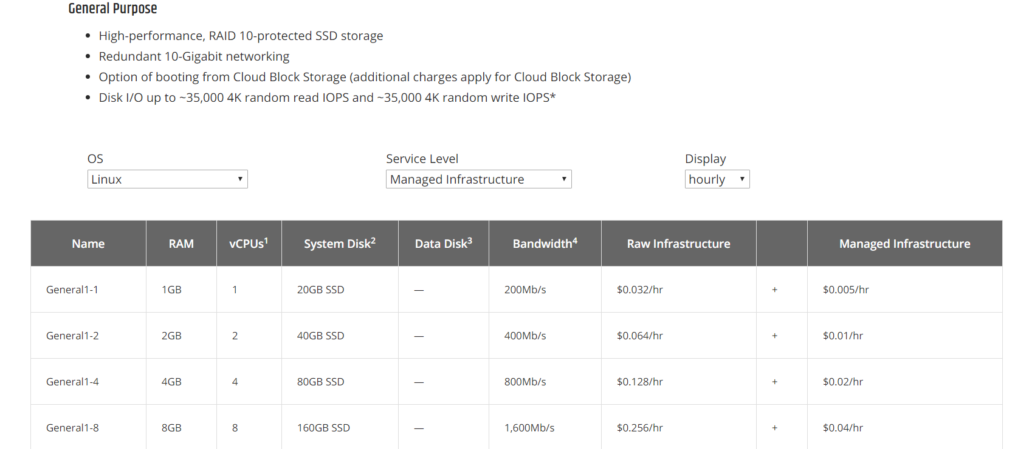

Google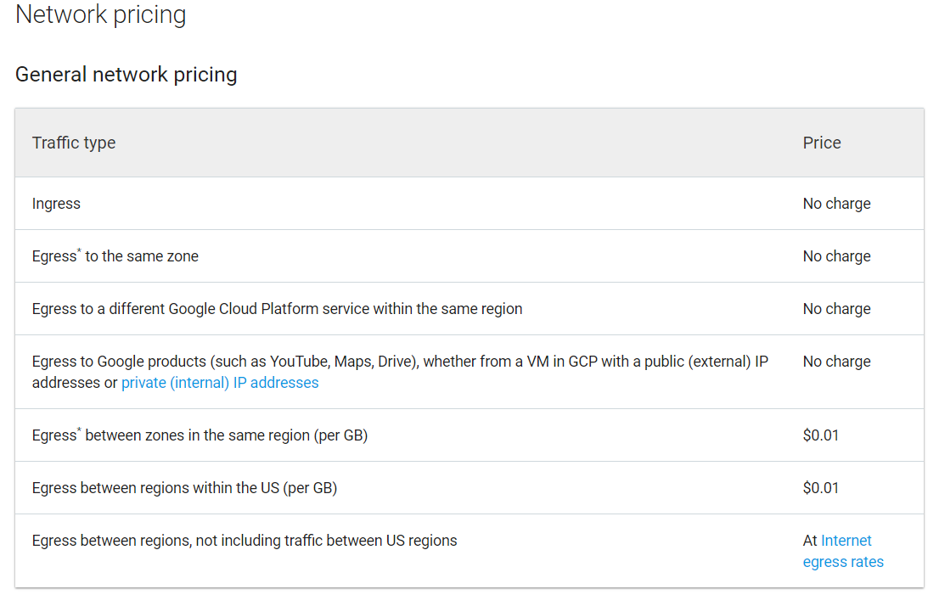

* Developer Costs

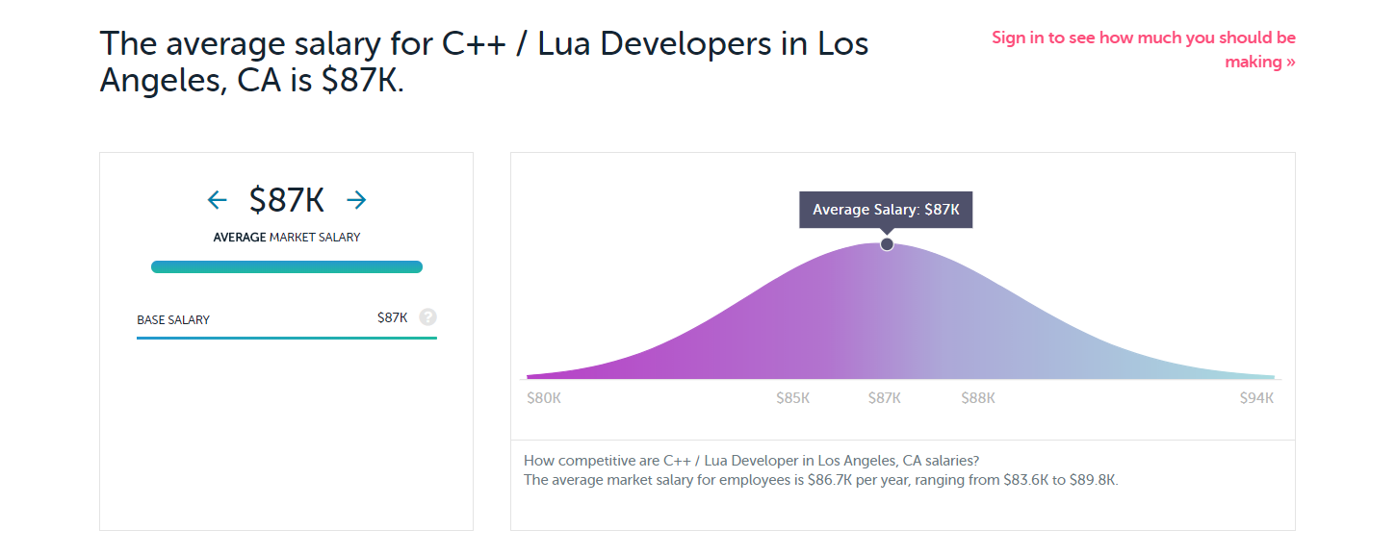

* Domain Name

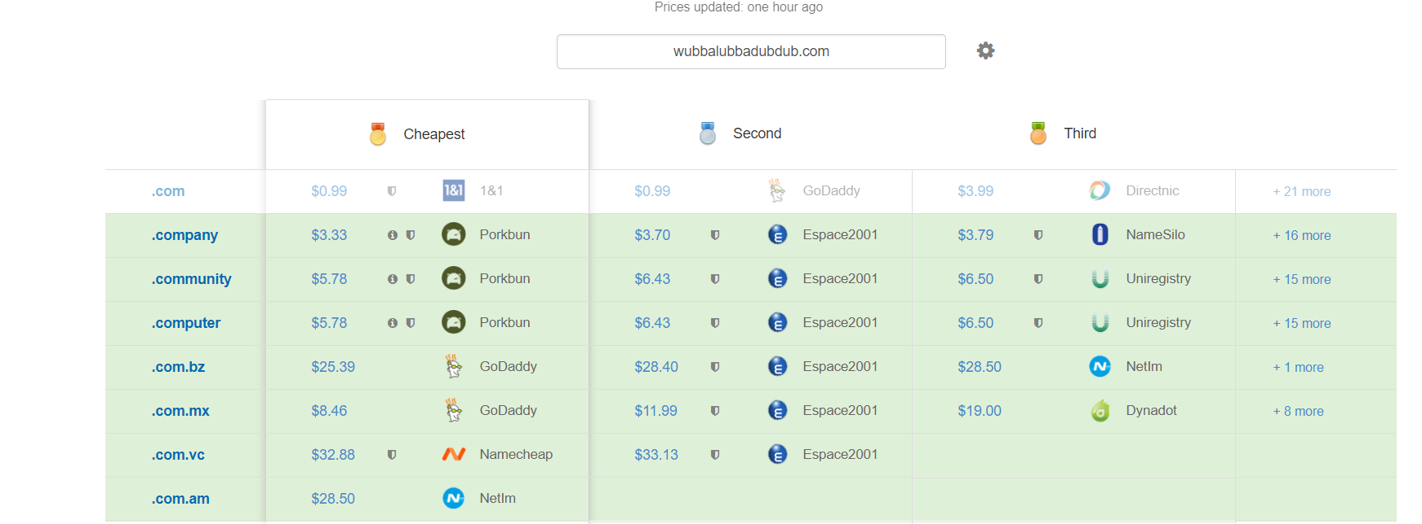

* Distribution
  + Steam Self Publishing ----- $100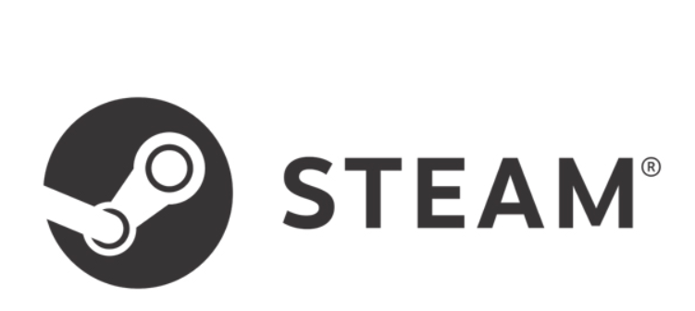
  + App Store ----- $99/year
  + Google Play Store ----- $25 registration fee + $99/year
  + Itch.io ----- Free depending on how much service we want 